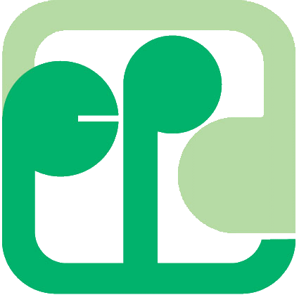
「充電池回收計劃」教材套外借申請表
Rechargeable Battery Recycling Programme Education Kit Loan Form for On Loan

請將填妥的申請表格傳真到 2318-1877 環保署廢物管理及策略組
Please FAX the duly completed form to 2318-1877, the Waste Management and Strategy Group, EPD

學校名稱
Name of School
地址
Address
電話  Telephone No. |  |  |  |  | 傳真  FAX No.
申請人姓名  Name of Applicant |  |  |  |  | 職位  Post
聯絡人姓名及電話  Name of Contact Person and Telephone No. |  |  |  |  |  |  | ( )

本人現申請外借教材套，並同意遵守以下規則：
I apply to loan out the education kit and agree to comply with the regulations stated below:
- 外借為期三十日，在沒有其他學校預訂的情況下，可最多續借三次。
The load period is 30 days. A maximum of 3 renewals can be arranged if the items are not reserved by other schools.
- 學校須把所借的教材套交回環保署廢物管理及策略組 (地址：香港金鐘道66號金鐘道政府合署高座21樓)。
The education kit must be returned to the Waste Management and Strategy Group, EPD (Address: 21st floor, High Block, Queensway Government Offices, 66 Queensway, Hong Kong).
- 申請人須負責保管所借的教材套。
The applicant is responsible for security of the borrowed education kit.

日期 Date |  | 申請人簽署及學校印鑑Signature of Applicant and Seal of the School

你在本表格提供的資料衹供處理這次申請之用
The information provided in this form will be used for processing this application only.

由環保署填寫
To be filled by EPD

借出日期  Loan Out Date |  |  | 歸還日期  Return Date
備註
Remarks

